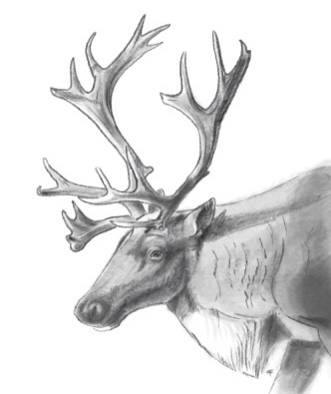

Meeting Minutes April 27, 2022
Attendees:
MLIB: Lisa Krebs, Scott McNay (Wildlife Infometrics)
BC: Loni Arman, Darcy Peel, Wayne Crossland
ECCC: Renee Lapointe, Lucy Reiss, Robin Steenweg, Jas Aulakh, Greg Rickbeil

Outstanding Actions
Date Assigned | Details and updates | Lead
Apr. 14-May 12, 2021 | BC to provide a written response to MLIB’s proposed Interim Measures Agreement (IMA), funding work plan, G2G (not being the mechanism BC wants for agreement) and Sec 11 – 7.2 MOU.  - Update – on hold | BC
June 23, 2021 | BC to draft a MOU (term sheet) ID headers, parameters, roles, and responsibilities – other provisions to be worked on together  , for discussion at July 21st meeting  - July 21, 2021: 2 page term sheet tabled  - No meeting Aug 2021, federal gov’t entered caretaker convention on Aug 15; MOU on hold until Canada can participate.  - Oct 27, 2021: BC and ECCC to draft a term sheet together prior to presenting to MLIB at Nov 24th meeting.  - Nov 22, 2021: BC indicated via email they are working on a term sheet that will be provided to ECCC (i.e. will not be available for presentation at Nov 24 meeting).  - Nov 30, 2021: BC and ECCC discussed a draft term sheet and outline of a draft MOU  - For further updates, see below – MOU Agreement | BC
June 23, 2021 | MOU / Agreement  - 3 Governments are looking for an agreement  - Conversations have occurred regarding an IMA, opening the G2G, and a MOU enabled by Section 7.2 of the Canada-BC Conservation Agreement for Southern Mountain Caribou  - We believe a section 7.2 MOU is the path to reach agreement and a mechanism to support planning and implementing recovery actions  - Jan 19, 2022: An agreement arising from Sect 7.2 requires legal review [at least from BC’s legal counsel] prior to discussing at this table  - Feb 2, 2022: a draft MOU is with BC legal counsel for review; defer future discussion until their review is complete  - April 27, 2022: Loni to check on status of BC legal review and provide timeline back to group | BC/ECCC
January 19, 2022 | Heather to check in with T8 group to make sure caribou will be a stand-alone piece outside of T8 negotiations  -MLIB Chief & Council asked this at a special meeting on Jan 31 – this table will need an answer  -April 27: Loni to look into this as Heather has changed positions | Loni
February 2, 2022 | Response to Submission of Technical Report  - April 27, 2022: ECCC provided summary, have a few questions and suggestions for clarification, but no substantive concerns – high quality report.  - Response from BC? | BC/ECCC
February 2, 2022 | Loni to talk with Ryan on providing a quarterly update to this table regarding decisions in the territory.  - April 27, 2022: Ryan no longer part of G2G table – Loni to ask Jen Pollard | Loni
March 30, 2022 | Park Expansion  - Brian to provide timber harvesting volume info for area (Spectrum report) | Brian
April 11, 2022 | Loni to check on funding through the T8 table – is it a form of accommodation? | Loni
April 11, 2022 | Loni to check on MOU – need timeline | Loni
April 11, 2022 | Scott to provide list of Wildlife Infometrics reports that have been prepared to inform MLIB / this table, and who they were sent to | Scott McNay

Overview of Tripartite table from February 2021 – Loni
- Review of Powerpoint; Loni will circulate for revision after the meeting (complete, see attached “BC Presentation MLIB_2022.pptx”

- Lisa will provide concise overview of MLIB’s Interests, which have been refined substantially beyond those presented (complete, see attached “MLIB summary of Caribou Recovery Interests.docx”)
- Includes a call for consent-based decision making and co-management framework between MLIB/BC/ECCC
- MLIB requests have been provided to the federal Minister, and Chief Chingee is meeting with the Minister tomorrow (April 28, 2022)
- The table has been put on hold multiple times, due to fire, federal and provincial elections, G2G
- Funding is not ongoing, which is a limiting factor…
- The tripartite table was initiated in summer 2020, and FY2021/22 is really year one for projects. Concerns with the Partnership Agreement date back to 2019.
- In Aug 2020, Maya Stano produced an interim measures agreement, sent to Province, still no response beyond a very high level one page word document from Bryan Williams.

BC funding opportunities – Lisa/Loni
- Review of 2 pager – what we did and what we want to do
Year 1 (2021-22)
150k BC and 150k ECCC – Total Costs - $450k
Additional funds identified by Nikanese: ~$160k for [Burnt Pine] mat pen siting / materials / construction

Work completed in 2021-22:
- Habitat stewardship – developed tactical plan for restoration, building out from Core habitat - completed. Aerial recce of priority areas has been completed (i.e. field work to verify tactical plan info). Spatial data has been passed over to Spectrum; they are now verifying and developing prescriptions and getting ready to apply for authorizations
- Picked a site for demonstration of habitat restoration techniques close to Mackenzie, road has been partially ripped, need to plant, and need signage
- Have delivered reports to BC summarizing the demonstration site and tactical plan – Scott to provide to this group
- Have hired consultation to look at other strategies / methods for predator reduction, and primary prey management (reports are being completed)
- Looked at introducing aerial surveys to monitor winter recreation and have developed a survey technique (reviewed by BC and ECCC) - has been implemented – very interesting results; final report to come in the summer.
- Looking at maternity pen site to help reintroduction of caribou in Burnt Pine, have done desktop exercise for potential sites, have completed aerial recce and groundwork to refine boundary, and have purchased material as well
- Reports have been delivered to BC and pen site report will be soon delivered
- Year 2 – looking for BC to commitment for funding
- MLIB wants to hire a coordinator – need multi year funding. Can’t develop programs and capacity without a long term commitment.
- 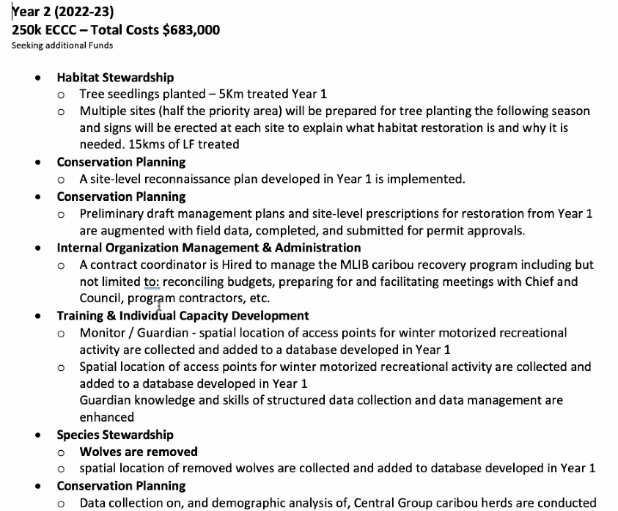
- Year 2 (to be completed in 2022-2023?)
- Focus is on implementing recommendations from reports & planning exercises from Year 1 – including primary prey, predator reduction, snowmobile monitoring
- Scott will provide a list of the reports and who they were sent to – Lisa to send to Loni
- Based on projects that were identified during the February 2, 2022 tripartite meeting, BC has requested a total of $478K? in funding through MIRR’s Indigenous Funding Envelope (IFE), as follows:
  - BC Caribou Recovery Program has submitted request for approval of funding for Restoration ($118K?), Burnt Pine Mat pen ($185K?) and the Ethno study ($35K?)
  - Through the Treaty 8 common table, capacity building (coordinator ($50K?) and guardians ($30K?)), ungulate surveys ($50K)
  - Through the G2G table, $45K? for CRLUO’s.
- Loni to check on the funding through the T8 common table – will it be tied to accommodation?

Phase 1 Technical Report review – Robin
- Summary of report – see attached “Status of Caribou and Habitat in MLIB territory.pptx”

- Overall impressions: report is comprehensive and well written; thanks to MLIB and WI for commissioning it

- Robin to summarize questions and provide them to MLIB (Scott) and reconvene as tech folks to discuss

- Caribou movement between ranges – most movement between Kennedy Siding and Burnt Pine, also includes visits by Kennedy Siding after Burnt Pine was considered extirpated
- Question, in light of discussion over Burnt Pine: When is a herd declared extirpated in eyes of federal government?
  - Under SARA, the units of interests are not herds, they are entire populations (“listed species”)
  - There is a listing process; currently the species is listed as Woodland Caribou, Southern Mountain population which includes multiple herds and population units
  - For the purposes of SARA, the species would only be listed as extirpated if every herd in the species was extirpated.
  - However, the federal recovery strategy does indicate herds that have been extirpated or functionally extirpated – not sufficient breeding females left (basically the same criteria as the Province) – even though the species as a whole is still listed as Threatened
- Would translocation or other direct recovery actions be contemplated for an extirpated herd? (e.g. Kennedy Siding to Burnt Pine)
  - It makes for harder decisions when considering extirpated herds and limited resources. However, extirpation itself doesn’t mean actions wouldn’t be taken. Would look at the feasibility of reintroduction and likelihood of success, including levels of habitat disturbance; also consider values and priorities of MLIB – not a black and white decision
- Caution highlighted: we are dealing with tactical level, imperfect data – field verification needs to be completed. Especially in Burnt Pine, which has a high density of seismic lines – field verification may show that there is significantly less disturbance than the desktop analyses show; for example, some were field checked and now have 4-6 m trees – they are well along the path to natural regeneration
  - Suggest highlighting this nuance further in the report – would show more potential for recovery in Burnt Pine, while not taking away from the overall message that significant recovery actions are needed.

Next meeting
- Need timeline for MOU and Parsnip
- Next steps: start talking about MOU.
- Loni will look into where the MOU is at and provide timeline to group.
- May 11th meeting cancelled. Loni to reach out to group the week of May 16th for next meeting (Scheduled May 25th)

